Kevin Hou

Professor David Guy Brizan

CS245

10/5/2021

Assignment 1

* Bubble sort (slowest)
* Insertion sort
* Selection sort
* Quick sort (Fastest)
* Merge sort

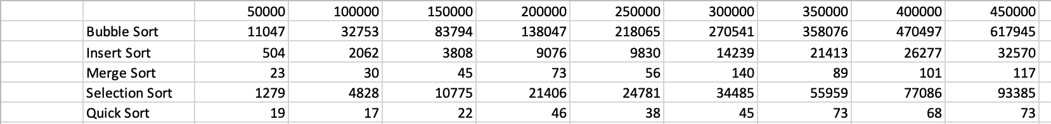

New Merge Sort Algorithm

* Step 1 first find the different regions, save in a arrayList
* Step 2 merge two regions every time
* In mergeregion function
  + copy one region into arrLeft
  + Graphical user interface, text, application

    Description automatically generatedCopy next region into arrRight
  + Merge arrLeft and arrRight into temp
  + Copy temp back to array
* Repeat mergeregion function until all regions are merge into one region
* New merge sort’s performance is similar to merge sort’s performance
* Bubble sort is still the slowest

